Zucchini Burgers Patties

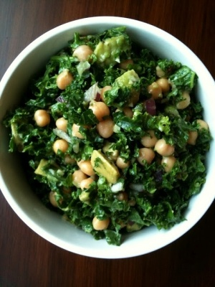

For approximately 10-12 Burgers:
8 Zucchini Squash
3 Shallots
1 onion
6 cherry tomatoes
2 slices of Bread
1/2 cup of spelt flour ( maybe add a little more to help hold together)
Dash of Cayanne Pepper
1 tsp of paprika
1tsp of tumeric
4 table spoons of onion powder
2 tsp of Sea salt
Directions:
Cut up Zucchini and blend in blender, add shallots and cherry tomatoes in blender once blended, pour in bowl, and cut up onion in small cubes, add to bowl, Crumble up bread in bowl, add alll other ingredients and mix with spoon or fork. Let the mixture sit for approx. 15 minutes, make into patty balls and fry in olive oil once mixture is room temp, as you would a hamburger. If mixture is very loose, add more flour. Serve on bread or but with lettuce and tomatoes.
Side Note: You can also shred zucchini with a grader and follow the same direction above.

Recipe by : Yahnyce YisraEL, 2012

